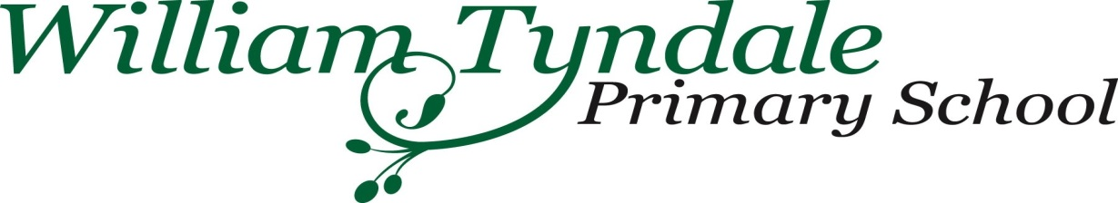

# 

**Universal Free Meals Registration Form**

**Please could all parents and carers complete this form. Completion of this form also enables us to check for Free School Meal Eligibility and whether the school can claim additional money (Pupil Premium) from the Government.**

Pupil Premium is the additional funding given to schools for pupils who have been registered as being entitled to Free School Meals (FSM) at any point in the last 6 years. Schools receive this funding to support their eligible pupils and narrow the attainment gap between them and their peers. Further information about how the school spends these monies can be found on the school website.

**We urge you to complete this form even if your child does not have school meals.**

To register please complete the boxes below using black ink and BLOCK CAPITALS and return it to your school

|  |  |  |
| --- | --- | --- |
| **Parent/Guardian Surname:** |  | |
| **Parent/Guardian Date of Birth:** |  | |
| **National Insurance Number:**  **OR**  **National Asylum Seeker Support Reference** **Number (NASS):** |  | |
| **Child(ren)’s Name(s)** |  |  |
|  |  |

For eligibility criteria please see overleaf

**DECLARATION:**

I confirm that the details supplied are correct and accurate. I understand that my personal information is held securely and agree that the school can only use the information provided to process my claim for Pupil Premium by contacting Strictly Education 4s, who will check entitlement via a secure government website.

I understand that I am responsible for informing the school immediately if I stop receiving one of the qualifying benefits.

By signing this form I am confirming that I have read and fully understood the above declaration.

Signed Parent/Guardian 1 ……………………….. Signed Parent/Guardian 2………………………..

Date………………………….. Date …………………………………

**N.B**. **This form must be signed by the person who is in receipt of the qualifying benefit**

|  |
| --- |
| **ELIGIBILITY CRITERIA – DOES EITHER PARENT RECEIVE ANY OF THE FOLLOWING?**  ✓  **IF YES PLEASE TICK RELEVANT BOX BELOW** |
| * Universal Credit with an annual net earned income of no more than £7,400 |
| * ✓ * Income support |
| * Income based Jobseeker's Allowance (IBJSA) |
| * Income related Employment and Support Allowance (IRESA) |
| * Support under Part VI of the Immigration and Asylum Act 1999 |
| * The guarantee element of Pension Credit |
| * Child Tax Credit (with no Working Tax Credit) with an annual gross income of no more than £16,190, as assessed by HMRC   N.B. If you receive WORKING TAX CREDIT you do NOT qualify even if you receive child tax credit and your income is below £16,190 |
| * Working Tax Credit run-on (paid for the four weeks after you stop qualifying for Working Tax Credit) |

|  |
| --- |
| * Is your child a looked-after child (LAC)? I.e. in the care of, or provided with accommodation by an English local authority? |

|  |
| --- |
| * Has your child ceased to be looked after by the local authority because of adoption,   a special guardianship order, a child arrangements order or a residence order? |

|  |
| --- |
| **FOR PUPILS IN YEAR GROUPS RECEPTION TO YEAR 11**   * Are either or both parents regular members of HM Forces and designated as   personal category 1 or 2 (PStat Cat 1 or 2), in the armed forces of another nation  and stationed in England or in receipt of a child pension from the Ministry of Defence? |

**Copyright © Strictly Education 4s Limited [2019]. No unauthorised copying permitted** Free School Meal Eligibility Checking Service (Updated February 2019)