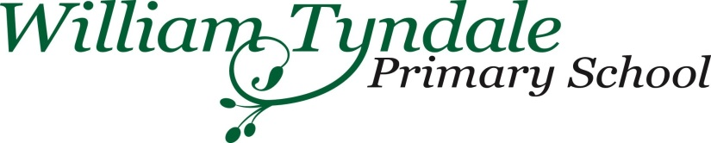
Admissions Supplementary Information Form

This additional form is to be completed in addition to the Common Application Form (CAF) from your local authority if you wish your child to be considered under item 4 of the over subscription criteria. Children eligible to be registered for free school meals. This form must be returned to William Tyndale School, Upper Street, London N1 2GG by 15th January 2022
Surname of child

First name of child

Date of birth of child

Address
Postcode |  |  | Contact telephone number
Name of Parent | Parent 1 |  |  | Parent 2
Parent’s date of birth | Parent 1 |  |  |  | Parent 2
National Insurance number of parent or National Asylum Seeker support reference number (NASS) |  | Parent 1 |  |  |  |  | Parent 2
NI number or NASS will be used to check your child’s eligibility to Free School Meals
DECLARATION:
I confirm that the details supplied are correct and accurate. I understand that my personal information is held securely and agree that the school can only use the information provided to process my claim for Pupil Premium by contacting Strictly Education 4s, who will check entitlement via a secure government website.
I understand that I am responsible for informing the school immediately if I stop receiving one of the qualifying benefits.
By signing this form I am confirming that I have read and fully understood the above declaration.

Signed: Parent/Guardian 1…………………………Signed: Parent/Guardian 2…………………….
Date ……………………… Date…………………
N.B. This form must be signed by the person who is in receipt of the qualifying benefit
*Free school eligibility for the purposes of the school’s admission policy you are considered to be entitled to free school meals if you or your child receive the following:
- Universal credit with an annual net earned income of no more than £7,400
- Income Support
- Income-based Jobseekers Allowance
- an Income-related Employment and Support Allowance
- support under part V1 of the Immigration and Asylum Act 1999
- Child Tax Credit (provided they are not entitled to Working Tax Credit) and have an annual income that does not exceed £16,190 (as assessed by Her Majesty’s Revenue and Customs);
- where a parent is entitled to the Working Tax Credit run-on ( the payment someone receives for a further four weeks after they stop qualifying for Working Tax Credit);
- the Guarantee element of State Pension Credit

