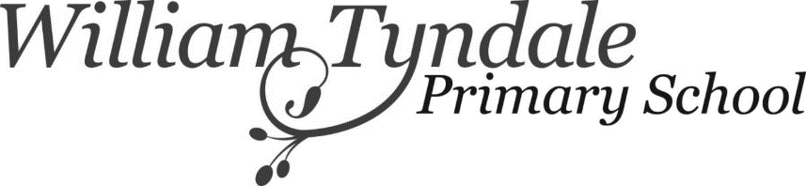
February Half Term Play Scheme Booking Form
Monday 14th – 18th February 2022, 8am – 4pm
Please complete and return this form to kidsclub@williamtyndale.islington.sch.uk.
Places will be allocated on a first come first served basis and you will receive a confirmation email from SchoolMoney.
The full balance must be paid in full as soon as possible through SchoolMoney. Please be aware that all Kids’ Club and Breakfast Club accounts must be cleared.
Child’s full name: | Date of birth: | Age:
Sibling full name:  (If applicable) | Date of birth: | Age:
Sibling full name:
(If applicable)
Parent/ Carer name: | Contact Tel No:

Please tick the days you would like to book £190 for week or £38 per day

 | Monday  14th February | Tuesday  15th  February | Wednesday  16th  February | Thursday  17th  February | Friday  18th  February
Child’s Name

Sibling Name
(If applicable)

Sibling Name
(if applicable)

