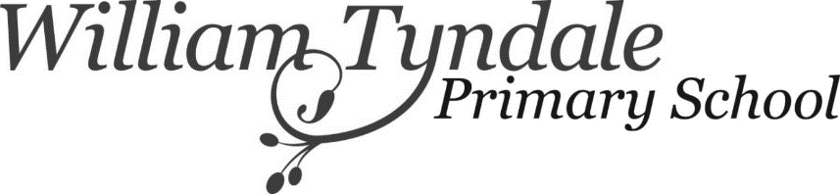
Summer Play Scheme Booking Form
Monday 18th - 29thJuly 2022, 8am – 4pm
Please complete and return this form to kidsclub@williamtyndale.islington.sch.uk.
Places will be allocated on a first come first served basis.
You will receive notification of your booking through School Money however, your place will not be fully confirmed until full payment has been received.
** Please note payments for the play scheme are non-refundable.
Child’s full name: | Date of birth: | Age:
Sibling full name:  (If applicable) | Date of birth: | Age:
Sibling full name:
(If applicable)
Parent/ Carer name: | Contact Tel No:

Please tick the days you would like to book £190 for week or £38 per day
Week 1
 | Monday  18th July | Tuesday  19th July | Wednesday  20th July | Thursday  21st July | Friday  22nd July
Child’s Name

Sibling Name
(If applicable)
Sibling Name
(if applicable)

Week 2
 | Monday  25th July | Tuesday  26th July | Wednesday  27th July | Thursday  28th July | Friday  29th July
Child’s Name

Sibling Name
(If applicable)
Sibling Name
(if applicable)

